

USer Guide

Software Developer - Music Player



Contents

Getting Started 2

Installing Songs 2

Listening to Music 2

Listening to a single song 2

Listen to a playlist 3

Creating a playlist 4

Searching for songs 6

Controlling playback 7

Device Power 8

# Getting Started

The Rebmem music player is pre-installed with the software required to function. No download is necessary. Ensure that the device is fully charged for first time use.

Once the device is fully charged, turn the music player on. You will be greeted with three buttons, the “All Music”, “My Playlists”, and “Search” options. This means that your device is functioning correctly.

## Installing Songs

The music player has 6 songs installed for a starting music selection to get you started. In order to add your own songs to the music player, a device such as a computer or laptop will be required. A device with Windows 10 Home / Professional (x64) installed is recommended.

1. Insert the device into a USB port on your computer or laptop.
2. Open file explorer.
3. Review the navigation on the left, and (Likely below Local Disk) find “REBMEM Music Player” device.
4. Open that folder to navigate to the music player homes directory.
5. Open the resources folder.
6. If this is your first time using the device, then this folder with have 6 files.
7. To add songs to your device simply drag them into this folder.
8. Once finished, remove the music player from your device.
9. The next time the device is turned on, it will notice the new songs and update its indexing.

# Listening to Music

It is quick and easy to select a song or playlist and start listening. First, ensure the device is turned on and you are on the Home screen. You can notice the home screen as you will be greeted with three buttons, the “All Music”, “My Playlists”, and “Search” options. If you are on another screen, you can return to the home screen using the button located at the bottom right of the device with the ‘Home’ icon.

## Listening to a single song

1. Click on the ‘All Songs’ button on the display screen.

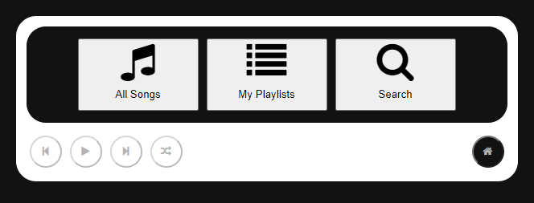

1. Click on one of the songs.

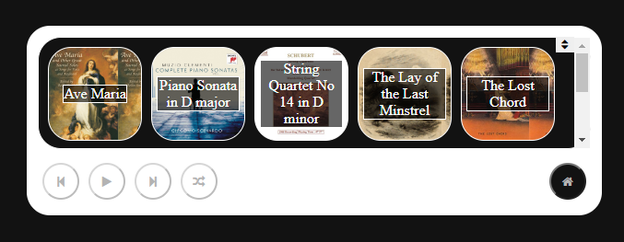

1. Click the ‘play’ button.

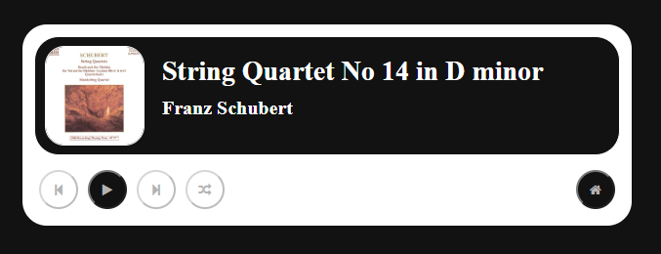

## Listen to a playlist

1. Click on the ‘My Playlists’ button on the display screen.



1. Click on one of the playlists. If you haven’t created any playlists yet, refer to “Creating a playlist”.

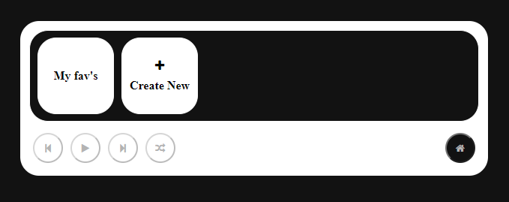

1. Click the ‘play’ button.

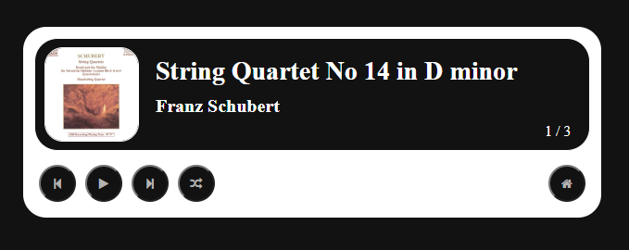

# Creating a playlist

Want to group your songs into playlists so the music always fits the mood? Then you’re going to want to create a playlist, following this simple guide. First, ensure the device is turned on and you are on the Home screen. You can notice the home screen as you will be greeted with three buttons, the “All Music”, “My Playlists”, and “Search” options. If you are on another screen, you can return to the home screen using the button located at the bottom right of the device with the ‘Home’ icon.

1. Click on the ‘My Playlists’ button on the display screen.



1. Click the ‘Create New’ button.



1. Drag multiple songs from the right column to the left column.

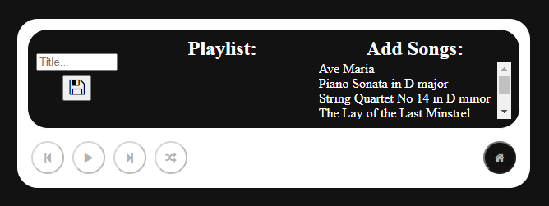

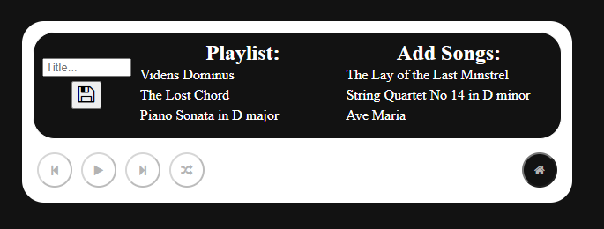

1. Input a playlist title into the title field.

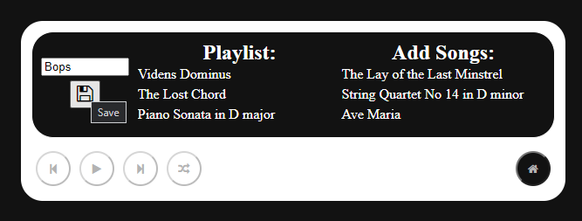

1. Click the save button. You are sent to the ‘My Playlists’ view with the new playlist.

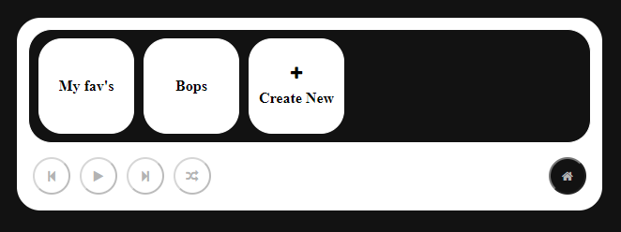

# Searching for songs

If you have lots of music on the device then finding songs by search term is useful and easy. First, ensure the device is turned on and you are on the Home screen. You can notice the home screen as you will be greeted with three buttons, the “All Music”, “My Playlists”, and “Search” options. If you are on another screen, you can return to the home screen using the button located at the bottom right of the device with the ‘Home’ icon.

1. Click on the ‘Search’ button on the display screen.



1. Input a search term and click the search button / press Enter.

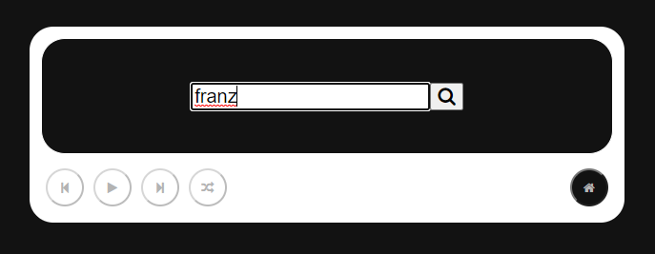

1. Select a song from the search results.

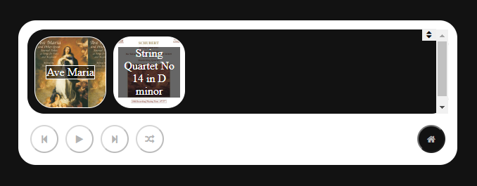



# Controlling playback

Once you have selected a song or a playlist, the buttons located at the bottom left of the device will now be usable. Going from left to right, these buttons are ‘Previous’, ‘Play/Pause’, ‘Next’, & ‘Shuffle’. If you only selected a single song, and not a playlist then the only button available will be the ‘Play/Pause’ button. Below is what the screen looks like for a playlist (with the buttons labelled).



**Previous**

**Play/Pause**

**Next**

**Shuffle**

**Previous**: This button allows you to play the previous song in the playlist. If at the start of the playlist, you skip to the last song in the playlist.

**Play/Pause**: This button allows you to play and pause the selected song in the playlist.

**Next**: This button allows you to play the next song in the playlist. If at the end of the playlist, you skip to the first song in the playlist.

**Shuffle**: This button allows you to shuffle to a random position in the playlist.

# Device Power

In order to conserve the battery life of the music player, after 30 seconds receiving no input the display screen will switch off however music will continue to play. In order to wake up the device simply interact with any of the buttons.